Why is a improvement required in this filed:

The compact size of a **handheld weather** device is another **advantage**. Being so small in size, the meter is easy to carry and without any compromise on quality and functionality. Instead of lugging heavy equipment around, the device is pulled out of a pocket or backpack and attached to a smartphone.

With a limited intervals of time we have update alias we would have full control over the weather.

Main Aims of this project:

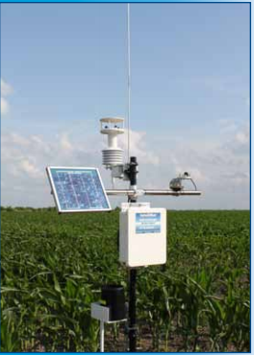

* Agriculture is basic real life motto of our project.
* Self driving car is basic tech improvement which can be done